**SIM MindSports Cup 2025**

|  |  |
| --- | --- |
| **Event Condition**  (Indicate Accordingly) | **Day** ~~/ Overnight~~ |

**\*Please indicate in the ‘Special Requirement’ section for the request of an overnight venue.**

**There will be additional venue cost for overnight event\*\***

|  |  |  |  |  |  |  |  |  |
| --- | --- | --- | --- | --- | --- | --- | --- | --- |
| **Venue Requirement (SIM CAMPUS) *Do note to use one row for each venue request** | | | | | | | | |
| **Venue Name / Type / Capacity** | **Purpose** | **Start Date (dd/mm/yyyy)** | **End Date**  **(dd/mm/yyyy)** | **Start Time**  **(hhmm)** | **End Time**  **(hhmm)** | **Estimated Turnout** | **Logistics Requirement** | **Special Requirements** |
| SR B.2.07/B.2.08 | International Chess competition | 5/10/2024 | 5/10/2024 | 08:00am | 06:00pm | 70 participants + 6 organizers | Grey foldable table x 22  Grey Chair x 75  Table Skirting (Maroon colour) x 2  Signage Stand (A3 Landscape) x 3 |  |
| SR B.2.09/B.2.10 | International Chess competition (Resting Room) | 5/10/2024 | 5/10/2024 | 08:00am | 06:00pm |  |
|  |  |  |  |  |  |  |  |  |
|  |  |  |  |  |  |  |  |  |
|  |  |  |  |  |  |  |  |  |
|  |  |  |  |  |  |  |  |  |
|  |  |  |  |  |  |  |  |  |
|  |  |  |  |  |  |  |  |  |
|  |  |  |  |  |  |  |  |  |
|  |  |  |  |  |  |  |  |  |
|  |  |  |  |  |  |  |  |  |

|  |  |  |  |  |  |  |  |
| --- | --- | --- | --- | --- | --- | --- | --- |
| **Venue Requirement (External)** | | | | | | | |
| **Venue Name / Type** | **Purpose** | **Start Date (dd/mm/yyyy)** | **End Date**  **(dd/mm/yyyy)** | **Start Time**  **(hhmm)** | **End Time**  **(hhmm)** | **Estimated Cost** | **Application Lead-time** |
|  |  |  |  |  |  |  |  |
|  |  |  |  |  |  |  |  |
|  |  |  |  |  |  |  |  |
|  |  |  |  |  |  |  |  |
|  |  |  |  |  |  |  |  |

All requests are subjected to availability and approval. The **response** time for each request will generally take around **5 working days.**

Keep your booking request for each event to **no more than 2 submissions.**

|  |  |
| --- | --- |
| **Venues** Earliest start time at 0830hrs and latest end time is at 2200hrs for weekdays | latest end time at 1830hrs for Saturdays | No booking on Sundays or Public Holidays | |
| **Types / Capacity** | **Restriction to note** |
| Function Room (102-Pax) (48-Pax) |  |
| Grand Hall (858-pax) |  |
| Grand Hall Foyer A/B | * No music blasting or excessive noise generation |
| 4 Seminar Rooms (Combined / non-combined)  outside performing arts theatre |  |
| Lecture Theatre (112-Pax) (130-Pax) (134-Pax) (188-Pax) (192-Pax) (296-Pax) (299-Pax) (376-Pax) (498-Pax) (80-Pax) (60-Pax) | No food/beverages |
| Seminar Room (30-Pax) (48-Pax) (60-Pax) (PAT) | Student Activity Room (29-Pax) | Return the tables and chair to the original arrangement after use  No music blasting or excessive noise generation |
| Multi-Purpose Sports Hall (418-Pax) | No food/beverages e.g. Redbull/Soft Drinks/Isotonic Drinks  No external furniture allowed  7pm – 9pm daily, booking priority given to sports team |
| Multi-Purpose Hall A1/A2 (140-Pax) B1 (40-Pax) B2 (56-Pax) Foyer C |  |
| Tennis Court | Cease activity when there is heavy rain   * Cease strenuous activity when 24-hr PSI is above 100 or 1-hr PM2.5 above 55 |
| Koi Pond Area / Plaza / Bamboo Courtyard | * Cease strenuous activity when 24-hr PSI is above 100 or 1-hr PM2.5 above 55 * No music blasting or excessive noise generation |

|  |  |  |
| --- | --- | --- |
| **Logistics** | | **AV Equipment** |
| Grey foldable table | Queue Pole | Projector |
| White foldable table | Signage Stand (A3 Landscape) | Projector screen |
| Square Table | Flipchart stand | In-house projector & screen |
| Yellow chair | Whiteboard | Wireless Handheld Microphone |
| Grey Chair | Platform | Wireless clip on Microphone |
| Table Skirting (Maroon colour) | Yellow metal barricade | Microphone Stand |
| Partition | Fan | In-house Sound System |

**Booth Venues in Blk A**

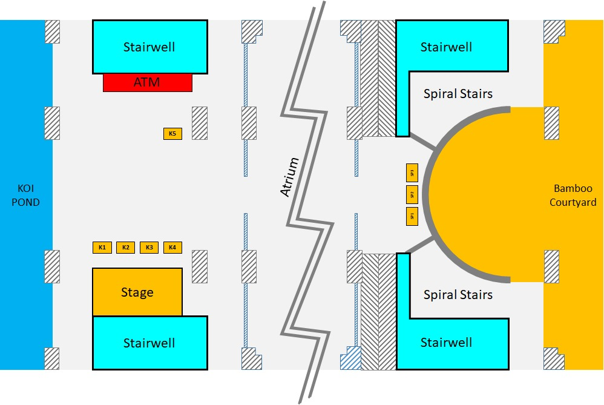

**Booth Venues in Student Hub**

